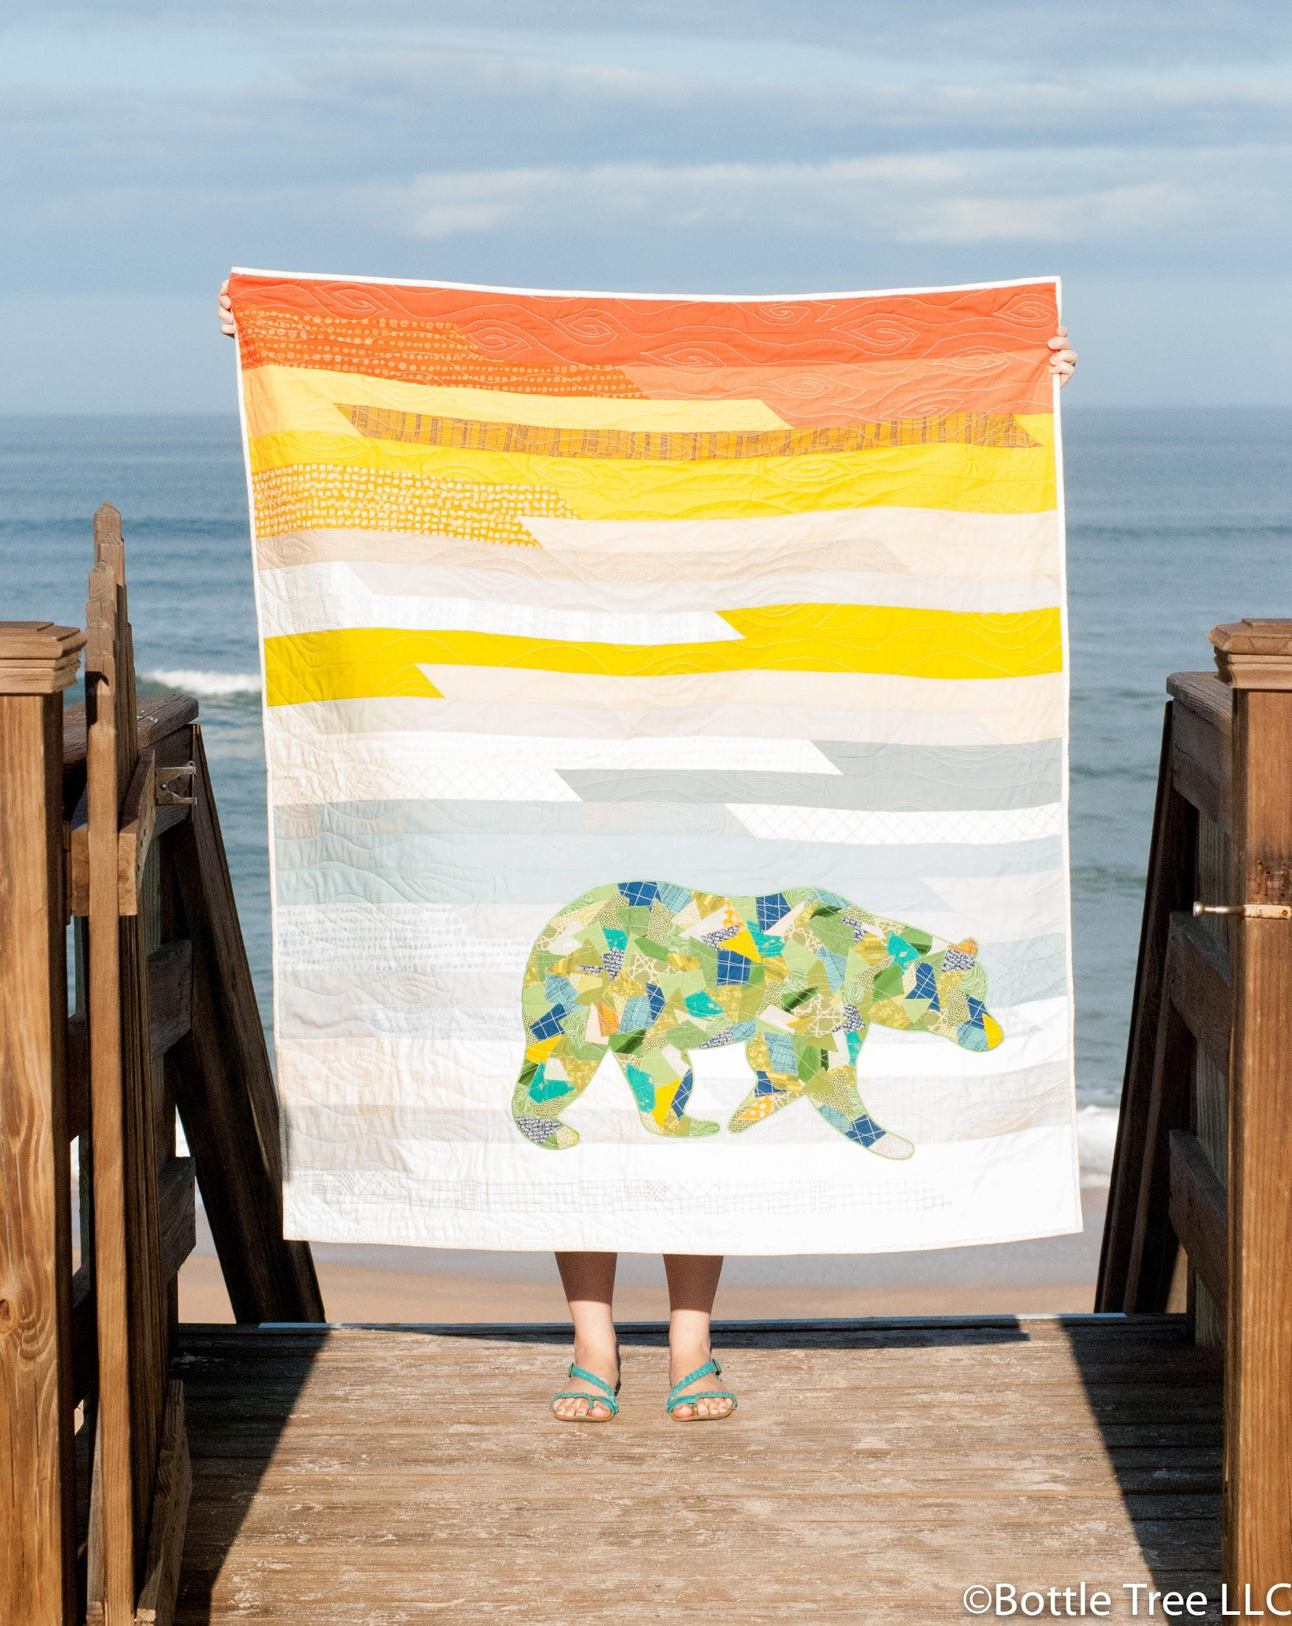
Scrappy Applique Workshop

Your book cover image will be
placed here.

Instructor: Sandra Miller

Class Description
- This class is perfect for beginner quilters as well as more advanced students interested in learning this raw-edge applique technique.
- Students will learn Shannon Brinkley’s simple and fun raw-edge applique technique, basic quilting techniques, and basic free motion quilting.
- Students will take away the finished or nearly finished quilt top!
- Students will be able to choose from a variety of templates (purchased the day of the workshop from Sandra, or ordered/downloaded (PDF) and printed beforehand from shannon-brinkley.com.
).
-Students will have a blast choosing beautiful fabric that, once collaged together, will create a really striking and modern look.

Class Length
4-6 hours

Class Supply List

Size Options | Wall Hanging 30”x40” | Crib/Child 36”x54” | Lap  50”x60”
Background fabric | 1 yd | 1 ½ yds | 3 yds
Backing fabric (includes 6” overage) | 1 ½ yds | 1 ¾ yds | 3 ¼ yds
Batting (includes 6” overage) | 36” x 46” | 42” x 60” | 56” x 66”
Binding fabric  (2 ½” strips) | ⅓ yd | ½ yd | ½ yd

-Scrappy Bits Applique by Shannon Brinkley (recommended for reference and required if you are making a pattern from the book)
-One Applique Template (available at shannon-brinkley.com/shop or from Sandra on the day of the workshop) *not needed if you are using a template from the book, Scrappy Bits Applique
-Various fabric for the applique piece (5-10 fat eighths would be perfect) *see Scrappy Bits Applique, pg. 16, for suggestions on fabric selection
-Thread that coordinates with the collage fabric
-Bobbin thread
-A large teflon sheet or parchment paper

The following supplies are in the Scrappy Applique Kit available for purchase on the day of class.
-2.5 yards fusible web (I recommend Mistyfuse with a teflon sheet or parchment paper)
-2 yds lightweight, non-woven, fusible interfacing (I prefer Pellon 906f)
-1 yd tear away iron on stabilizer (I recommend Sulky Totally Stable)
-clear polyester thread

Other Supplies students will need to bring:
-iron
-large pressing surface (an old towel is ideal)
-scissors
-rotary cutter
-straight pins
-basting pins or spray
-marking utensil
-plastic baggies for extra cut collage pieces
-Machingers Gloves (optional, but recommended if free motion topstitching and/or quilting)
-Dritz Fray Check (optional)

Classroom Preparation
Each student needs their own sewing machine, iron, and pressing surface. Set up common cutting stations. Students will need a little over a yard of table top space to themselves.

Class Agenda (All times listed are rough estimates; depending on class length and student pace, we may not finish, but students will be taught all the skills required and will be able to reference the book or pattern to finish at home.)

-Introductions (15 min)
-Class overview and demonstration (15 min)
-Prepare materials (pg 22) (30 min-1 hour)
-Trace template (20 min)

Break (if needed)

-Create your applique piece! (pg 29). (45 min)
-Topstitch the applique piece. Discuss the different options for topstitching (pg 34). Lesson and demonstration on free motion quilting and how to use that to topstitch. (1 hour).
-Cut out and baste the applique piece to the background fabric. (15 min)
-Embroider around the applique piece. (30 min)

*Materials Preparation
This is optional but helpful to make the most of the class time.
- Apply fusible web to the back of your collage fabric. If you have more than the recommended amount of collage fabric (5-10 fat eights), cut 4” strips of 8-10 (or more, if desired) different fabrics. Then apply the fusible web according to the manufacturer’s instructions.
- Trace your template onto your interfacing. Be sure to use a marking utensil that will not disappear or smear.
- Prepare background. If you want to place your applique piece on a pieced background, like in the above picture, prepare the background before class. For ideas and free patterns, see shannon-brinkley.com.

